Use this reference to create a course section roll over. Workday may refer to this as Course Offering Roll Over.

Table of Contents:
[CTRL + click to jump to content)
How to Roll Over Course Sections 1
How to Publish Rolled Over Courses 6

How to Roll Over Course Sections
- In the left-hand menu, locate and open the “CLI Staff” dashboard.

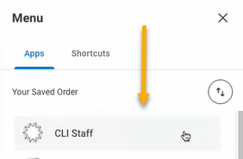

- Click the “Courses” tab and click “Find CLI Course Section Offerings to Roll Over” under the Course Sections heading.
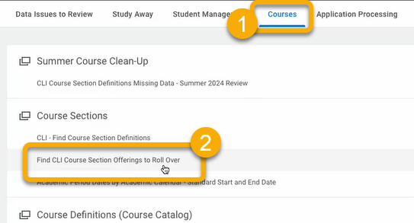

- The Find CLI Course Section Offerings to Roll Over window will appear.
Click the Academic Period field and select the academic period that has the courses you intend to roll over.
TIP: If the courses are in more than one academic period, follow these steps for each academic period.
TIP: Use the course tags to aid your search. If not in use, leave these fields blank.
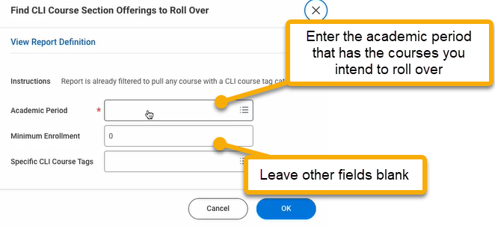

- Click “OK”.

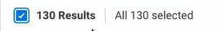
- On the next page, use the Current Search filters to display courses intended for the roll over.
When finished, check the box to select all displayed courses.

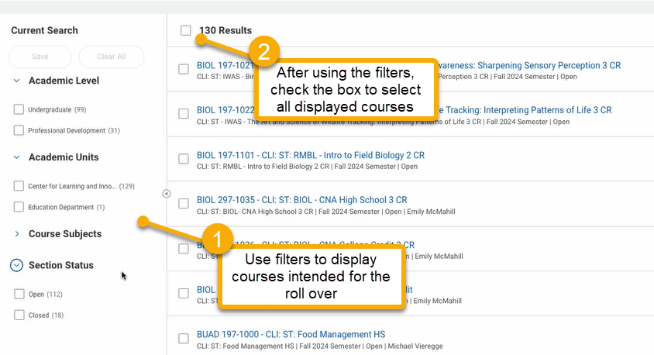

- Click “Roll Over Course Offerings” at the bottom of the page.


- On the next page, select the Target Academic Period field and enter the academic period into which you want to roll over the selected courses.
Leave all other checkboxes blank.
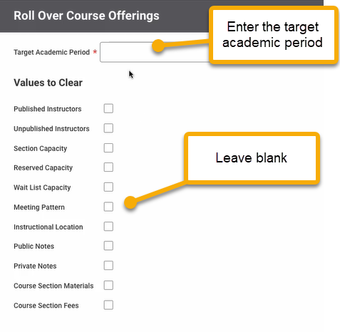

- Click “OK”.

- On the next page review the courses that will roll over, as well as those already created in the targeted academic period (if any). After reviewing, click the “Confirm” checkbox.
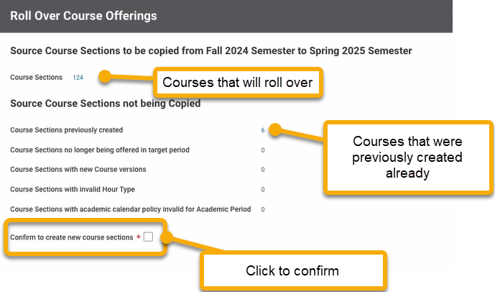

- Click “OK”.

- Click “Done”.

 IMPORTANT: Workday® requires a few hours to roll over the selected courses into the targeted academic period. Changes will not be immediately accessible.

How to Publish Rolled Over Courses
When courses successfully roll over, they are NOT automatically published. Instead, they receive “preliminary” status.
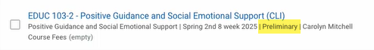
Follow these steps to publish roll over courses and to make them available for registration.

- From the left-hand menu, open the CLI Staff dashboard.


- Under the Courses tab, click CLI – Find Course Section Definitions under the Course Section heading.
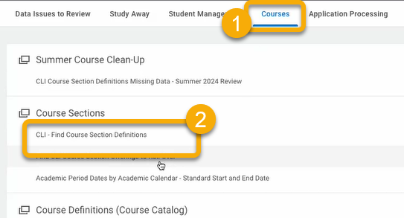

- Use the filters to display only courses with preliminary status. Unpublished roll-over courses have preliminary status.

- Select all displayed courses by checking the box at the top of the search results.

- Click “Mass Publish Course Sections”.

